# **Name: Abdurrahman Qureshi**

# **Roll No: 210451**

Practical No: 15

**1)Execute and show the output of the following code:**

**CODE:**

import java.net.*;

import java.io.*;

public class URLDemo{

public static void main(String[] args)throws MalformedURLException{

URL hp=new URL("http://www.javatpoint.com/javafx-tutorial");

System.out.println("Protocol:"+hp.getProtocol());

System.out.println("Port:"+hp.getPort());

System.out.println("Host:"+hp.getHost());

System.out.println("File:"+hp.getFile());

System.out.println("Ext:"+hp.toExternalForm());}}

**OUTPUT:**

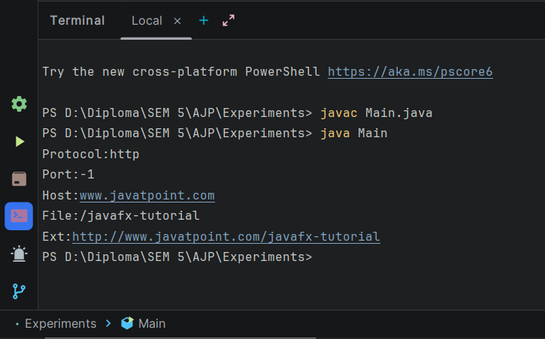

**2)** **Write a program using URL class to retrieve the host, protocol, port and file of URL** [**http://www.msbte.org.in**](http://www.msbte.org.in)

**CODE:**

import java.net.URL;  
import java.net.MalformedURLException;  
  
public class Main {  
 public static void main(String[] args) {  
 try {  
 URL url = new URL("http://www.msbte.org.in");  
  
 String protocol = url.getProtocol();  
 System.*out*.println("Protocol: " + protocol);  
  
 String host = url.getHost();  
 System.*out*.println("Host: " + host);  
  
 int port = url.getPort();  
 if (port == -1) {  
 System.*out*.println("Port: Not specified");  
 } else {  
 System.*out*.println("Port: " + port);  
 }  
 String file = url.getFile();  
 System.*out*.println("File: " + file);  
 } catch (MalformedURLException e) {  
 System.*out*.println("Invalid URL: " + e.getMessage());  
 }}}

**OUTPUT:**

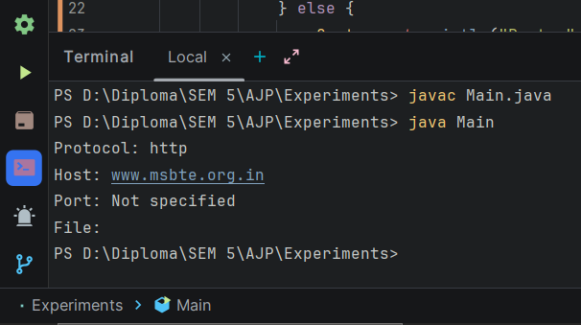

**3) Write a program using URL and URLConnection class to retrieve the date, content type, content length information of any entered URL.**

**CODE:**

import java.net.*;  
import java.util.*;  
import java.io.*;  
public class Main{  
 public static void main(String args[]) throws MalformedURLException,IOException{  
 String url;  
 String input = "http://github.com";  
 System.*out*.print("\n Enter URL: ");  
 url=input;  
 URL a=new URL(url);  
 URLConnection uc = a.openConnection();  
 System.*out*.println("Content-type: " +uc.getContentType( ));  
 System.*out*.println("Date: " + new Date(uc.getDate( )));  
 System.*out*.println("Content-length: " +uc.getContentLength( )); }}

**OUTPUT:**

